News Release

Gebroe-Hammer Associates Marks Midyear with $917+M in Multifamily Sales
54 Deals involve 6,052 Units across New Jersey/Greater Philadelphia Region
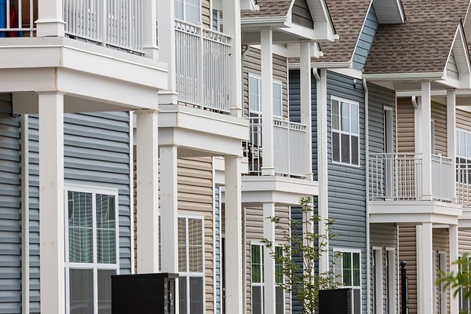
The Residences at North Village in Sparta, sold for $14.65M during Q2, is one of 54 deals arranged by Gebroe-Hammer Associates in 2021 thus far.

Livingston, N.J., July 28, 2021 – Multifamily revenue-stream clarity and reinforced pricing have fed a reported $917+M in apartment-property transactions for Gebroe-Hammer Associates as of midyear – doubling sales over the same period last year. In total, the nationally ranked multifamily-focused investment brokerage firm has arranged 54 deals involving 6,052 units during the first two quarters of 2021.

“As expected, multifamily investment volume and demand has more than just ‘picked up,’ it has skyrocketed thanks to positive performance metrics, the proverbial light at the end of the pandemic tunnel getting brighter, strong gains in effective rents and a continued low-interest rate environment, which should extend well into the foreseeable future,” said firm President Ken Uranowitz, who has experienced every recessionary period since joining Gebroe-Hammer Associates at its inception 46 years ago.

“While a number of notable economists projected a 25% to 33% increase in multifamily sales over last year, Gebroe-Hammer’s market specialists have shattered this benchmark and are reporting a robust pipeline of exclusive and rare-to-market listings that will extend this streak through year end,” he said.

From January through June, Gebroe-Hammer’s market specialists have been active across the entire state of New Jersey, long considered a haven for former Manhattanites priced out of New York City’s gentrified boroughs. Sales spanned North, Central and South Jersey as well as the Greater Philadelphia Region.

According to Uranowitz, the multifamily recovery continues to accelerate in a positive direction. He attributes this to vaccine rollouts, a lack of single-family home supply and affordability and a long-term, very accommodative Fed monetary policy. As is typically the case, certain markets nationwide have fared better than others, most notably the New Jersey Metro.

“Considered an edge-city market, the Garden State offers plenty of big-city urban-living options in the form of suburban transit-village settings,” said Executive Managing Director David Oropeza. “Suburbs offer rent savings, more living space, top-ranked walkable neighborhoods, proximity to central business districts and – perhaps the most-important lifestyle amenity – access to outdoor spaces for gatherings and recreation.”

Another phenomenon feeding the tenant cohort in urban suburbia is “unbundling,” which refers to the wave of post-bachelor’s degree career starters who are moving out of their parents’ homes. This mid-20-something Gen-Z cohort benefitted from telecommuting, sought comfort with family and established a nest egg during the past 12-14 months that is now being allocated for apartment rent.

As a result, Gen Z is filling the gap left by midlife millennials driven into the single-family homebuying market during the pandemic. Despite the surge of millennials who sought to buy a home, many were unable to do so in a market where supply is falling extremely short of demand and a significant percentage lacked enough cash for a downpayment. Consequently, established millennials have remained an important part of the renter pool.

“The tenant pipeline is extremely healthy, extending across two highly educated cohorts with existing or immediate-future upper-income earning potential,” said Joseph Brecher, executive managing director. “Consequently, there is tremendous investor interest in Class A new-construction product as well as older existing properties that have been recently renovated with – or have the potential to benefit from implementation of – at-market features, especially in kitchens and baths and other in-demand amenities.”

Uranowitz added, “The psychological effect of getting vaccinated, returning to the office, dining in restaurants and a more normal way of life in general is boosting the desire to get back to doing business as usual – albeit, at a much more accelerative pace for no other reason than to catch up from last year’s economic and physical shutdown.”

For 46 years, Gebroe-Hammer’s brokerage activities have concentrated on all multifamily types to serve the investment needs of a long-term client base of institutional investors, private equity funds, REITs, family offices and private individuals. While initially focused on New Jersey, the Livingston, N.J.-based firm has evolved to also dominate the Eastern Pennsylvania and New York State submarkets as well as represent client interests nationally. Widely recognized for its consistent sales performance, the firm is a 17-time CoStar Power Broker and is credited with arranging the largest portfolio sale in 2020 with the highest per-unit price for the MidAtlantic Region and in New Jersey.

###

