News Release

Gebroe-Hammer Associates
2 West Northfield Road
Livingston, NJ 07039

Contact: Carin McDonald / carin@cmmstrategic.com / 973.406.5136

Gebroe-Hammer is a Leader in Greater Philadelphia Metro Multi-Family Sales for Latest Quarter
Market Specialists Arrange Transactions involving 627 Units/$104.98M

Philadelphia, PA, March 1, 2018 – While the Philadelphia apartment market recorded the second highest number of multi-family units sold in the Northeast at the close of last quarter – ranking only behind New York City – Gebroe-Hammer Associates orchestrated one-third of the metro’s overall transactions during the same timeframe. The firm’s Greater Philadelphia Market Team of Executive Managing Director Joseph Brecher, Senior Vice President Eli Rosen and Sales Associates Joseph Gehler and Eli Herskowitz represented the sellers and/or buyers in trades involving a total of 627 units, netting $104.98 million in sales.

The transactions, which spanned Philadelphia, Delaware, Montgomery and Burlington (NJ) counties, mostly involved apartment buildings primed for value-add repositioning. Each property is well-located within some of the metro’s most popular commuter- and transit-friendly neighborhoods.

“In terms of the Northeast, the Philadelphia Metro saw the second-highest volume of multi-family units sold to close out the latest quarter and ranked fourth overall in terms of transaction dollar volume,” said Rosen, an area market specialist whose focus has been the Philadelphia market for the past 14 years. “While Philadelphia edged out Boston and Northern New Jersey in terms of total units sold, the city led among the top four metros in terms of units-per-sale with an average of 154 per transaction.”

In addition to Gebroe-Hammer’s involvement in orchestrating the trade of over 400 units in Philadelphia’s University City section, the firm also arranged the sale of Colonial Gardens, located at 5427 Wayne Ave., in Germantown. The 71-unit, three-story property features a gated courtyard and is comprised of one- and two-bedroom layouts. Built in 1950, Colonial Gardens was last renovated in 1999 and the buyer plans to implement a complete renovation program in order to reposition the property.

Extremely walkable and historic in character, the neighborhood is rich in nearby transit options. There are several SEPTA stations and bus lines connecting to Center City, just six miles to the southeast. Rosen exclusively represented the seller and procured the buyer in the transaction.

Beyond Philadelphia proper, Gebroe-Hammer also arranged three separate transactions involving 58 units across Delaware and Montgomery counties. The brokerage team of Rosen and Gehler exclusively represented the seller and procured the buyer in the $2.86 million sale of 15 total units at Sycamore Court, 304 Old Lancaster Rd., in Merion Station, as well as the $2.35 million sale of The Oaks, a 21-unit apartment community located at 5 Chestnut Pike in Ridley Park. Gehler also recently orchestrated the $1.5 million sale of 22 units at 1238 Washington St., in Norristown.

Rounding out Gebroe-Hammer’s latest Philadelphia Metro transaction activity is a $5.375 million suburban bedroom-community sale involving 56 units at Pine Meadow Apartments. Located at 191 W. Hampton St., in Pemberton in New Jersey’s Burlington County, the garden-style community includes off-street parking, on-site laundry facilities and the convenience of a NJ Transit bus stop less than half a mile away. The sale was arranged by the brokerage team of Brecher and Herskowitz, who represented the seller and procured the buyer.

The Gebroe-Hammer Greater Philadelphia team represents clients with investment interests in their urban and suburban submarkets of specialization as well as those that extend throughout the Pennsylvania/New Jersey/New York State geographic area and the greater Northeast. Collaboratively, the team has effectively expanded the firm’s client base from private individual owners to now include REITs, private equity firms and institutional investment entities.

Gebroe-Hammer is the leading and most trusted multi-family investment sales brokerage firm in the Pennsylvania/New Jersey/New York State tri-state region. The firm specializes in suburban and urban high-rise and garden-apartment properties and also markets mixed-use and free-standing office and retail properties. Widely recognized for its consistent sales performance, Gebroe-Hammer is a 14-time CoStar Power Broker.

###

Apartment Q4 2017 – Northeast Sales
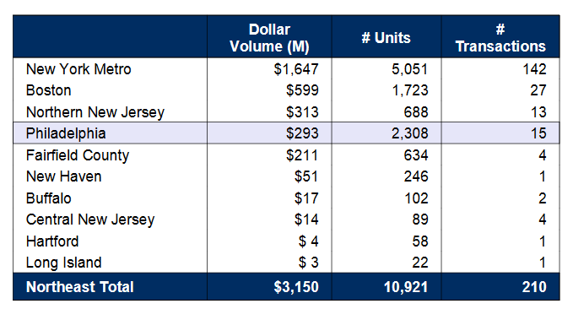
Source: Reis

